Neon Orange Generation

# Narrative Unit

## Characters

Main Character – Scientist at Theoretical Manufacturing

CEO – Leader of TheMan and ruthless businessman

Lead Scientist – Old mentor and friend to MC that disappeared under suspicious circumstances

Myst – Shadowy person that helps you from time to time

## Story Concept 1

You’re a scientist employed by TheMan (Theoretical Manufacturing) who is fed up with the company’s immoral business practises. While you’re working in the factory on the cliff which overlooks the city, you have a perfect view of an orange stream of goo seeping into the city from the facility. This is the last straw, so you go into the foundry to take the highly experimental graviton laser technology. Your meddling causes a malfunction with the containment tube resulting in the tube being compressed into a board-like shape.

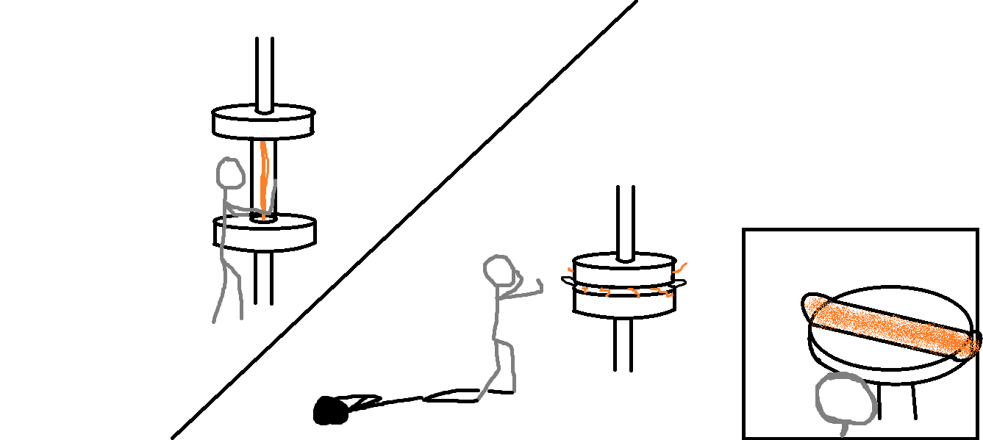

Armed with your new creation you descend upon the city, sticking it to TheMan by using their prized technology for fun. The graviton laser technology was created through a long and arduous process

## Story Concept 2

You’ve been surrounded in a dead-end alleyway by TheMan’s goons with no way of escaping. “Your little joyride is over now. May I have my property back now.” he said as more of a demand than question. “You’re not as almighty as you think. You may sway how things are run,”

## Story Concept 3

Myst - “You may just be using this as a release for what they did to you, but what you have there is more powerful than you know”